A000-Am,C-Taino-Pestle-Owl-Marble-1000 CE

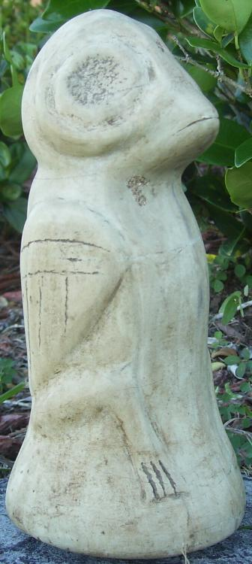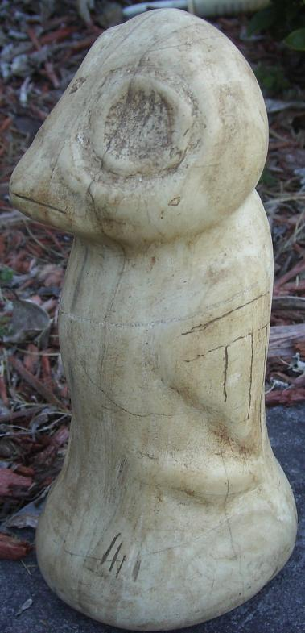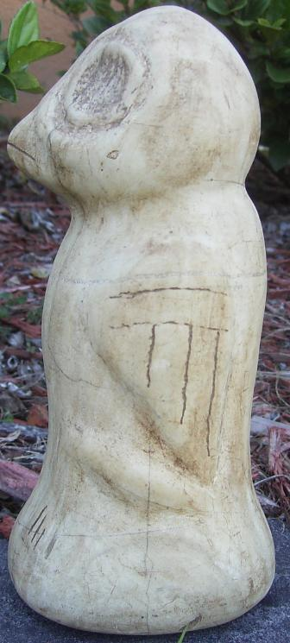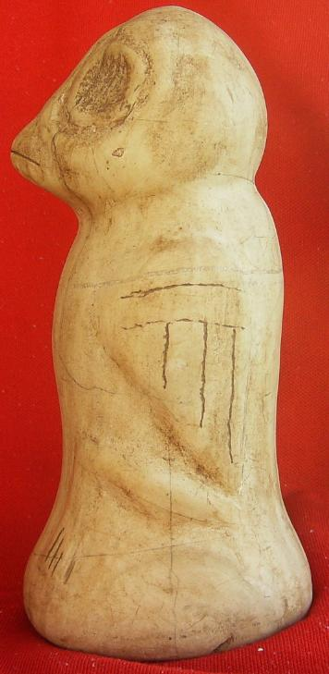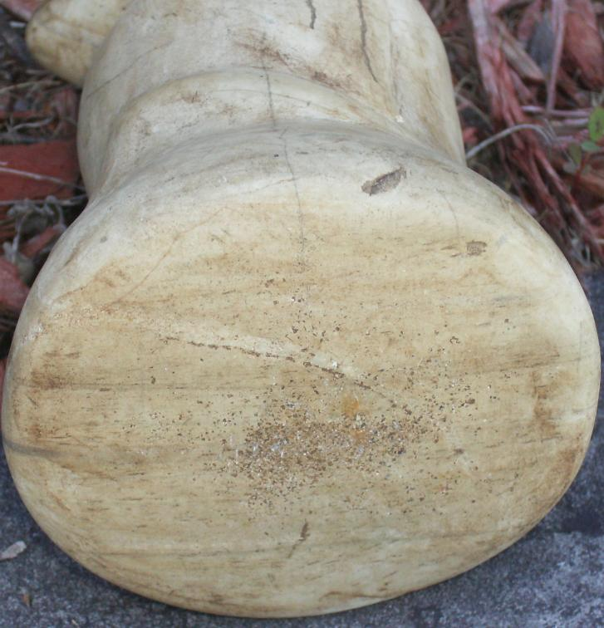

Figs. 1-5. Am,C-Taino-Pestle-Owl-Marble-1000 CE

Case No.: 18

**Accession No.**

**Formal Label:** Am,C-Taino-Pestle-Owl-Marble-1000 CE

**Display Description:**

Cemi owls were likely gods or spiritual representatives important to Taino cosmological inquiry. The consensus is they were not simply naturalistic owls, but symbolic representations. Owls were associated with the afterlife and allies of the *Bohique* who sought their aid during hallucinogenic ventures. This pestle was used in the preparation of cohoba from the seeds of the *Anadenanthera* tree of which the active hallucinogenic chemical is [bufotenin](https://en.wikipedia.org/wiki/Bufotenin) (5-HO-DMT, bufotenine) a tryptamine related to the neurotransmitter serotonin. It is an alkaloid found in the skin of some species of toads.

**LC Classification:**

**Date or Time Horizon:**

**Geographical Area:**

**Map:**

**GPS coordinates:**

**Cultural Affiliation:**

**Media:**

**Dimensions:** 7.25 in. high, 3.5 x 3 in. base

**Weight:**

**Condition:**

**Provenance:**

**Discussion:**

**References:**